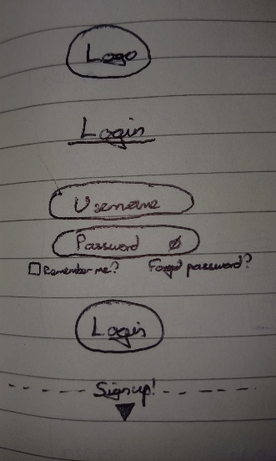
This is the general UI design for the Login and Sign-Up page

Login menu includes:
- Logo positioned at the top of the login box
- Title as ‘Login’ to clearly identify its use
- ‘Username’ field – text box to allow user input, curved edges for cleaner aesthetic
- ‘Password’ field – curved edges for continuity, and an eye icon for toggling hidden/shown text for user privacy when entering their passwords
- ‘Remember me' checkbox – tickable to allow the user to remain logged in over multiple sessions, improving UX, flashes or grows when clicked for visual confirmation of user actions
- ‘Login’ button – rounded ends, briefly darkens when clicked to symbolise data successfully sent, sends credentials to authenticator
- ‘Forgot password?’ – clickable link to user account recovery page, changes colour when hovered over
- ‘Sign up' button – clickable triangle which navigates to user sign-up page if user is not already registered

Design notes:
- Login box is centred on the web page
- Minimalistic design for user friendly focus
- Consistent colour palette throughout – in theme of game logo?
- All fields centre justified for ease of reading, except ‘Remember me' left justified and ‘Forgot password' aligned to the right for better use of space and visual satisfaction
- Modern font choice for professionalism as a corporate account management system for the larger company, not yet for the game

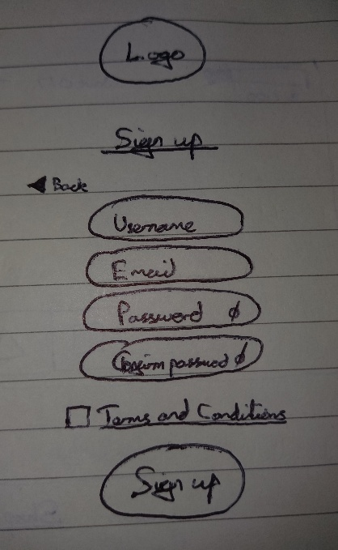
Sign-up menu includes:
- Logo positioned at the top of the sign-up box
- Title as ‘Sign Up' to clearly identify its use
- ‘Username' field – text box to allow user input, curved edges for cleaner aesthetic
- ‘Email' field – allows user to input an email address to associate their account with, same design as username and password fields
- ‘Password' field – curved edges for continuity, and an eye icon for toggling hidden/shown text for user privacy when entering their passwords
- ‘Confirm password' field – exactly as above, but for the user to confirm they wrote their password as intended when creating their account
- ‘Terms and conditions' checkbox – required to be ticked before credentials can be submitted, an acceptance of terms and conditions (data harvesting)
- ‘Terms and conditions' – clickable link to terms and conditions information, possibly a pop-up on the same page
- ‘Sign up' button – rounded ends, briefly darkens when clicked to symbolise data successfully sent, sends credentials to account creator tool
- ‘Back' button – clickable arrow which redirects user to the login page again

Design notes:
- Sign-up box centred on the web page
- Minimalistic design continued
- Colour theme continued as before
- All fields centre justified except ‘terms and conditions’ checkbox , aligned right for ease of placement, and ‘back' button for logical reasons, i.e. pointing to the previous screen
- Modern font choice, same as login page, to fit professional theme as part of the company product rather than the game

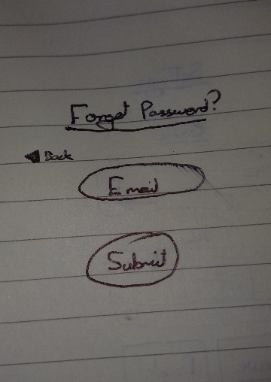
Account recovery menu includes:
- Title as ‘Forgot password?’ for clear purpose
- ‘Email' field – textbox with rounded edges, allows user to submit the username associated with their account
- ‘Submit' button – rounded ends, briefly darkens when clicked to symbolise data being sent successfully, sends an email to the user so they can recover their account
- ‘Back' button – clickable arrow which redirects user back to the sign-up page

Design notes:
- Forgot password box centred on web page
- Same minimalistic design continued for readability
- Same colour theme
- Fields centred, except ‘back' button for logical reasons
- Same modern font as before for professionalism and consistency, and to differentiate game and company

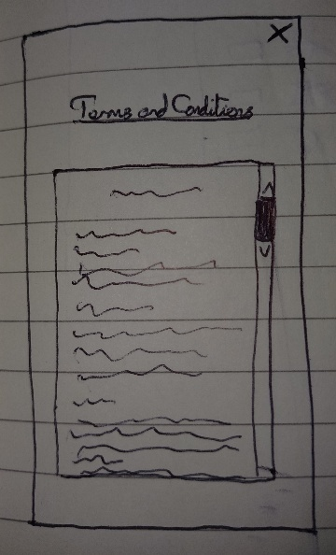
Terms and conditions page includes:
- Pop-up – opens on top of sign-up page for ease of access and use
- ‘Close’ button – X in top-right corner to close the pop-up
- Title as ‘Terms and conditions' for obviousness
- Large text field with scrollbar to display the full terms and conditions of the product to the user, scrollbar should darken when clicked to offer tactility and ease of use

Design notes:
- Pop up centred on web page to cover up the account creation menu
- Minimalistic, easy to read but with terms and conditions text small enough to discourage users from actually trying to read them all, i.e. hostile design
- Same colour theme
- Same font choice for modernity and consistency

This is the general UI design for the game startup menu
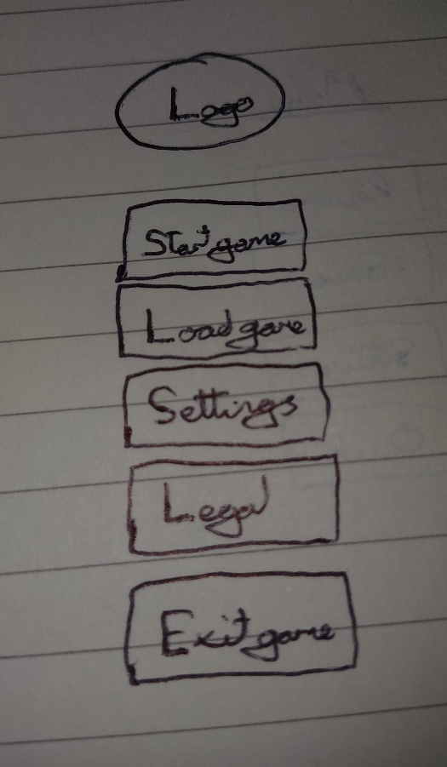
Start menu includes:
- Game logo centred at top of screen for emphasis
- ‘Start game' button – square edges for geometric theme of the game, and to be distinct from the account management screens, starts a new game from level one, darkens briefly when clicked for tactility
- ‘Load game’ button – square edges, briefly darkens when clicked, allows the user to resume a previous game that was saved on the game server
- ‘Settings' button – square edges, briefly darkens, navigates the user to the settings page to adjust accessibility and performance options
- ‘Legal’ button – square edges, briefly darkens, opens a pop-up for terms and conditions and data collection consent
- ‘Exit game' button – square edges, darkens, terminates the application.

Design notes:
- All fields centred on the screen
- Text centred within all boxes for more satisfying user interface
- Minimalistic and readable to maximise user experience and functionality
- Contrasting colour palette from the account management pages to differentiate the company from the game
- Background could be a snapshot from the game or in the same style as a level
- More casual, almost blocky or geometric font choice, to differentiate the game from the company account management tools, and give a more friendly, less intimidating experience
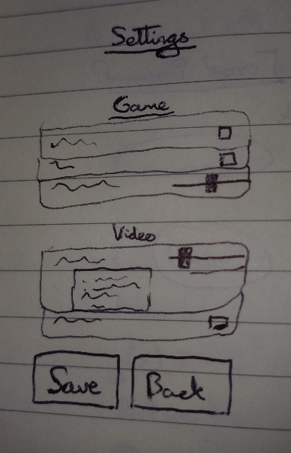

Settings menu includes:
- Title as ‘Settings' for clarity of purpose
- Subtitles as groups of settings, i.e. ‘game’, ‘video’, ‘audio' et cetera, for clear and logical groupings of similar settings for user convenience and guidance
- Names for each setting, i.e. ‘master volume', ‘enemy volume', ‘tower volume' et cetera, to clearly and obviously give purpose to each setting
- Pop-up descriptions for each setting when the setting is clicked, i.e. ‘master volume controls the volume of everything in the game' et cetera, to give user friendly experience and make it clearer to users what everything does; setting should darken when clicked and expand to accommodate the description, and to improve tactility and user experience
- Checkboxes for appropriate settings, i.e. ‘damage effects' et cetera, so these settings/game features can be easily toggled on/off
- Sliders for appropriate settings, i.e. ‘master volume' et cetera, so the user can intuitively click and drag to an appropriate level; slider should darken when clicked for additional tactility and improved user experience
- ‘Save’ button – square edges, briefly darkens when clicked to symbolise settings being applied successfully
- ‘Back' button – square edges, briefly darkens when clicked for tactility, minimises the settings menu and returns the user to the startup menu

Design notes:
- Title and subtitles centre justified to highlight them and keep consistent with other screens and views in game
- All settings in individual boxes to improve abstraction and make everything clearer, more readable and more usable for the user
- All setting names and descriptive text aligned to the left edge of the screen for more satisfying user experience, and ease of reading
- All checkboxes and sliders aligned to the right edge of the screen for contrast, readability and clarity
- Whole settings menu positioned centrally on the screen to cover the startup menu, but with the same background as the startup screen for satisfying continuity
- Same colour palette as the startup menu
- Minimalistic and user-centric for maximised user experience
- Continued casual font choice for consistency, and to ensure the game feels approachable, fun and easy to use

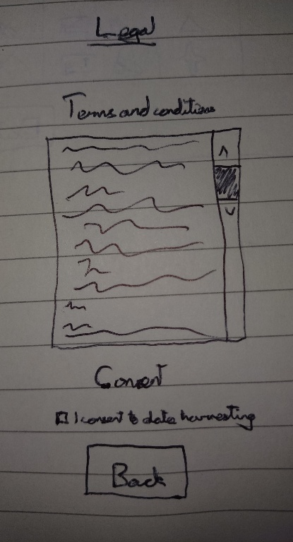
Legal page includes:
- Title as ‘Legal' to highlight purpose
- Subtitle as ‘Terms and conditions' for obviousness and ease of navigation
- Large text box with scrollbar containing all terms and conditions for the game, scrollbar should darken when clicked to signify user interaction, same as on sign-up page
- Subtitle as ‘Consent' to signify where the user can manage their consent
- ‘Consent' checkbox – signifies that the user give consent that their data can be harvested for the purpose of building a dataset to refine telemetry and game fairness, can be toggled on and off
- Description of what consent means and the uses of the data to keep users informed and well-inclined
- ‘Back' button – square edges, briefly darkens when clicked to signify user interaction and give tactility for user experience, returns user to startup menu screen

Design notes:
- Page centred on the screen, covers up the startup menu but keeps the same background for consistency
- Same colour palette as the rest of the game elements
- Minimalistic, easy to read for a friendly experience, but terms and conditions small enough to discourage users from reading them all
- Title centred, text in ‘terms and conditions' box aligned left for readability in large block text fields, ‘consent' tickbox positioned to the left for satisfying user interface
- Same professional font as the account management screens before for the full terms and conditions, but maintain the casual, fun feeling font for all the surrounding titles and other elements to ensure it does not feel intimidating, but is suitably professional and formal

This is the general UI design when the user is actively playing the game
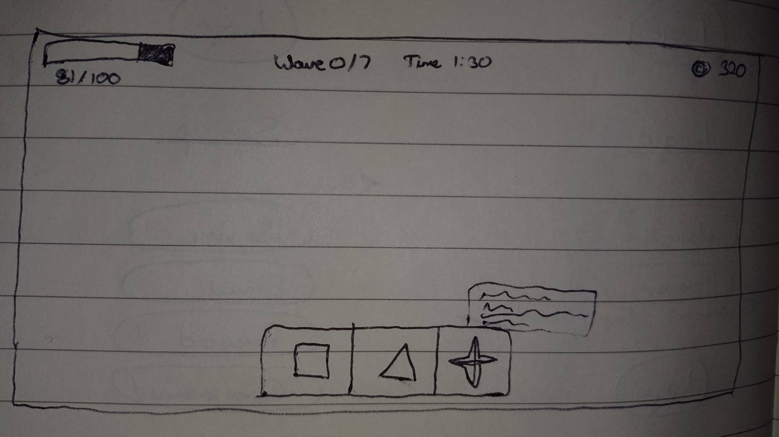
Game head-up display includes:
- ‘Health’ bar – indicates how much health the player has left, with a numerical counter alongside a visual bar, with remaining health red and lost health black to give full user transparency and ease of gameplay, when health bar drops to zero the game ends and the player loses
- ‘Round' counter – shows the player how many waves they have completed on the current level, and indicates how many remaining, allowing the user to better prepare
- ‘Money' counter – indicates how much money the player currently has, with a small coin icon for visual emphasis, should increment in real time
- ‘Tower selection’ bar – allows the user to drag and drop new towers onto the map to use them, depleting coins by buying more towers. Unlocked towers will be in full colour, ones yet to be unlocked will be greyed out to symbolise that they are not yet available to be bought, each tower will have an associated cost which is displayed at the bottom of its selection box, alongside a coin icon for full user experience and ease of understanding
- Description of each tower and all of its relevant statistics should be displayed when the user's mouse hovers over a tower box for a short period of time, giving full understanding ad control to the user
- ‘Time' counter – indicates how much time the user has left in the current wave, giving an indication of how long they have to survive

Design notes:
- Make full use of landscape screen size, but add tolerances for different screen sizes so elements are not cut off or rendered unreadable
- ‘Tower selection' bar centred at the bottom of screen to be the focal point during gameplay
- Timer and wave counter centred at the top of the screen to maximise readability for core gameplay information., likely to be read often in gameplay
- Coin counter in top right, out of the way as not frequently read by user but still readable
- ‘Health' bar positioned in top left for more common viewing, but out of the way of the game map itself as it is an opaque object and may obstruct otherwise
- All text in either black or white for simplicity, chosen according to the map colours to add contrast and readability, no background to avoid obstructing the map
- Text aligned to wherever the element is on the screen, i.e. left adjusted for elements on left of screen, centre aligned for elements in central plane, right adjusted for items on the right of the head up display
- All text elements to use same casual, blocky font style for continuity and consistency with the theme of the game
- ‘Tower selection’ bar to have translucent grey background in order to contain it, with each tower in its own box for clear viewing and user interaction, all boxes with square edges to continue blocky geometric theme
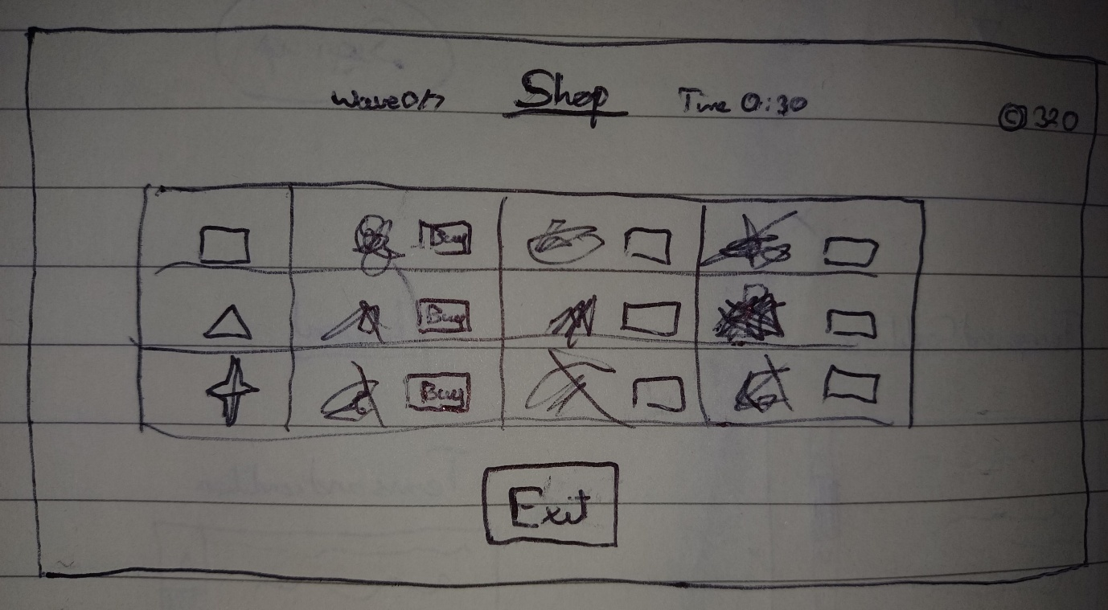

Game upgrade shop includes:
- Title ‘Shop' to clearly indicate the purpose of this screen
- Coin counter continued from main gameplay head up display for continuity and ease of reading
- Rows of upgrades according to tower type, i.e. square, star, trapezium et cetera
- Icons for each upgrade to indicate the effect of the upgrade, i.e. upward arrows next to a bullet to symbolise shooting speed et cetera
- A text box to describe to the user the effect of the upgrade for full transparency, ease of use and gameplay experience
- ‘Buy' button – square edges, darkens when clicked to indicate button has been pressed, states the cost of the upgrade with a coin icon alongside
- ‘Time' counter – shows how long left in this buy phase before the next wave
- ‘Wave' counter – shows how many waves have been completed to improve the user experience by helping them to prepare and manage their gameplay tactically
- ‘Exit' button – square edges, darkens when clicked for tactility and improved user interface experience, closes the buy screen and returns he player to the game, irrespective of any time remaining in that buy phase, essentially allowing the user to skip through, improving the user experience

Design notes:
- Shop menu centred on the screen, with neutral/blank background to symbolise a break in the game, give illusion of peace and quiet in a hectic game for a relaxed user experience
- All head up display elements carried over from gameplay screen remain in same positions, same sizes for continuity
- All text centrally aligned within respective boxes
- Continued casual font to keep the game engaging, fun and unique from the formalities of the overarching company
- Same colour scheme as previous menus for continuity and readability

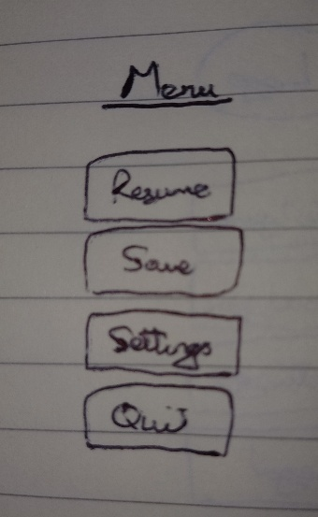
In game pause menu includes:
- Title as ‘menu' for clarity
- ‘Resume' button – square edges to continue theme of the game, darkens when clicked for added tactility, closes the pause menu and resumes the game immediately from the same point the game was paused at
- ‘Save' button – square edges for consistency, darkens when clicked to symbolise that the button was clicked to improve user experience, saves the player's current progress so the current game can be loaded from this point using the ‘load’ button on the game's main menu
- ‘Settings' button – square edges, darkens when clicked for user confidence, opens the same settings' screen as before, allowing the user to adjust gameplay settings while they are playing, so they can maximise their own user experience
- ‘Quit' button – square edges, darkens when clicked, exits the current gameplay loop when clicked twice, returning user to the main menu screen. A single click will produce a text pop up warning the player that any unsaved progress will be lost, and asking them if they are sure

Design notes:
- Centred on the screen with the game's current state as the background, but with all head up display elements hidden, and an opaque box behind the menu to make it more readable
- All text centred on the screen for consistency and maintaining readability throughout
- Same friendly, blocky, geometric font to keep consistent with all other game elements
- Continued colour palette from all other in-game menus to keep the user experience consistent and professional in its execution

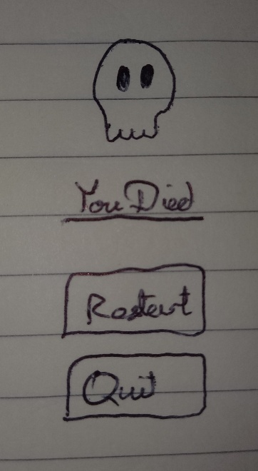
Player death screen includes:
- Death symbol for graphical interface and improved user experience
- Title as ‘You Died' to clearly convey the news to the player
- ‘Restart' button – square edges for consistency with prior menus, dims when user clicks it for added tactility for overall user experience, ends the current gameplay loop and starts a new one with all attributes reset to their original values
- ‘Quit' button – square corners for geometric theme in keeping with the rest of the game, darkens when clicked for a sense of interactivity and to symbolise button was pressed, exits the current gameplay loop and returns the user to the main menu screen

Design notes:
- Blank background to symbolise break from the gameplay loop
- All elements centred on the screen for consistency, readability, and being satisfying
- Same colour palette as all previous game interfaces for consistency, but tend towards darker shades to symbolise death and failure and misery
- Same blocky font in keeping with the rest of the game, to keep the death screen as friendly as any death screen can be
- Tend towards simplicity to better convey all information and make it as readable and accessible as possible

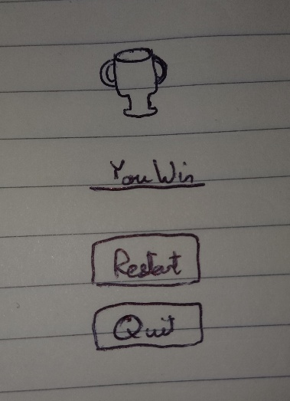
Player win screen includes:
- Trophy symbol to emphasise the user's win and add a graphical element to brighten the screen and make it more inviting and playable
- Title as ‘You Win' to clearly convey the user's victory
- ‘Restart' button – square edges to keep continuous with every previous game menu, darkens when clicked to signify that it was pressed to improve user experience, starts a new gameplay loop with all values set to their defaults again
- ‘Quit' button – square edges for consistency and geometric cues, darkens when clicked, returns the player to the original game main menu screen

Design notes:
- Blank background as an escape from the game world
- All elements centred, maintaining readability and satisfaction
- Consistent colour palette with the rest of the game, but with a tendency towards brighter shades to symbolise success and happiness
- Blocky, friendly, geometric font to stay consistent throughout and seem friendly and relaxed

